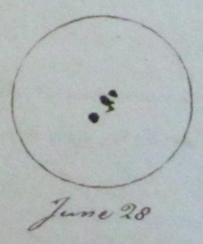
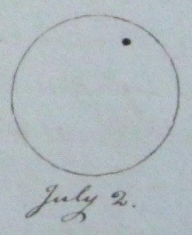
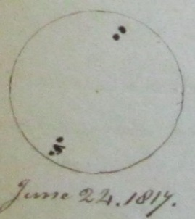
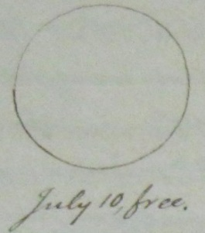
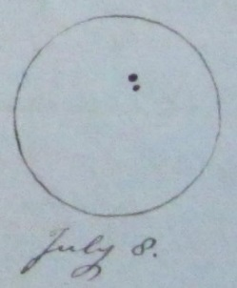
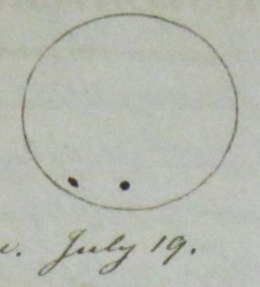
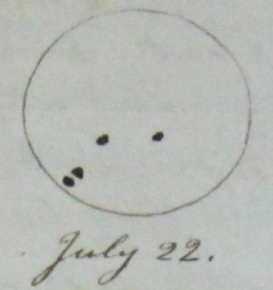
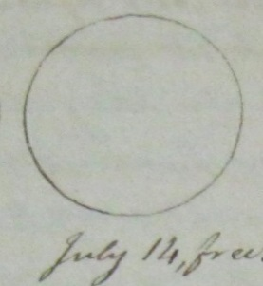
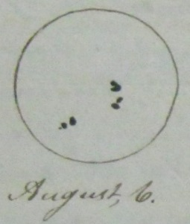
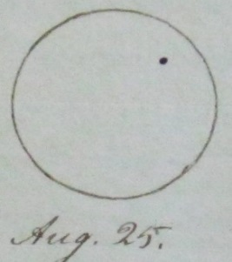
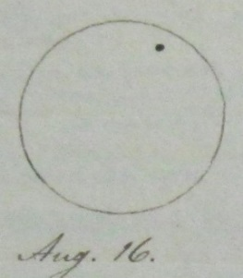
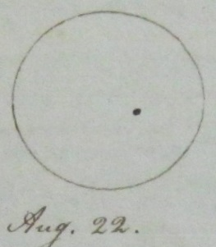
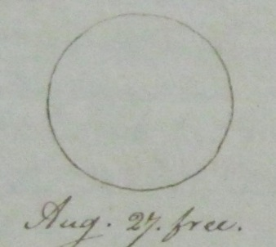
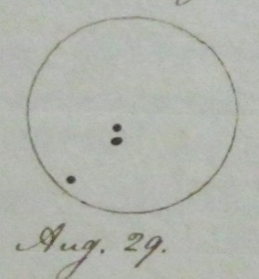
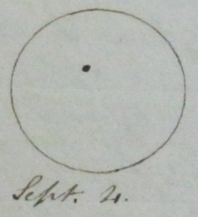
The summer of 1817 [sic, for 1816] was an unusually cold summer. During the course of it there was an observable dimming in the appearance of the sun; it shone not with the usual brightness. During the course of this dimming the spots on the surface of the sun were rather larger than common. Of the nature these spots there have been various conjectures. My own conjecture is this; That the Sun is a vast body off combustible matter, somewhat perhaps, like that which produces the lava from the burning mountains and that the surface of the Sun is as a vast oven of melted lava; that like terrestrial ignited substances, it diffuses light and heat in proportion to its size, the density of its burning matter, the measure in which it is ignited and the nature of the medium thru which its rays pass. That the spots consist of fragments broken by the operation of fire from parts of the sun below the surface of less gravity than the glowing lave of the surface, and so rising in it, and supplying the surface with new measures of fuel. I should think it possible that these fragments at first, if such they are, might diminish the intensity of hear at the surface but when they become inflamed, might increase it. According to this conjecture I have suspected that after subsiding or disappearing of spots on unusual size, or number, we might have a succession of warm summers. This, however, is but conjecture, grounded on a measure of analogy which perhaps is not applicable to the case. In the year 1817, with a spy glass, guarded (?) with a smoked glass, I observe the sun a number of mornings, soon after it has risen, and marked down the spots appearing on its disk, as accurately as I can. The times and appearances are as follows:
Though it is evident from the above appearances that the spots on the sun’s disk vary in size, shape, and location, within short intervals, it is also evident from them that the sun has a rotating motion from west to east. The spots of Aug 29, are probably the spots of Aug 6, 23 days previous, having nearly made one revolution in past, and decreased in size. Jon Fisher

