Early American Sunspot Drawings from the “Year without a Summer”
The year of 1816 is commonly referred to as the “Year Without a Summer” due to the abnormally cold temperatures the persisted in the northern hemisphere (Klingaman and Klingaman, 2013]. Particularly hard hit by this weather anomaly were the New England states where the lower than average temperatures had a devastating impact on agriculture and, in general, the quality of life. We have now come to an understanding that the natural decrease in temperature towards the end of the Little Ice Age (1300-1850) [Fagan, 2001] was exasperated by the April 1815 volcanic eruption of Mount Tambara in Indonesia. However not knowing this connection gentleman scientists at the time naturally considered that the sun may have played a role in the extreme temperatures particularly in light of the dearth of sunspots observed during what is now referred to as the Dalton Minimum (1790-1830) [McCracken and Beer, 2014].
The Reverend Jonathan Fisher was a Congregational minister who spent the bulk of his adult life serving the tiny coastal hamlet of Blue Hill in northern Maine [Murphy, 2010, Cathey, 2015]. He was a well-educated man with a profound love of science. Fisher made valuable contributions to the practical and intellectual developments of the eastern frontier in the early 19th century. In 1816 he experienced this dire summer and made continual reference to the cold weather in his journals. During the summer and into 1817 he also included in his journals sketches of “spots on the rising sun.” Figure 1 is a composite image of the solar drawings made by Fisher for the summer of 1816 and into the winter of 1816-1817. These simple sketches are, to the best of our knowledge, the earliest sunspot drawings from the Americas. The fact that Reverend Fisher’s journals were found to still exist is a story in and of itself which we will leave to others to relate. The Jonathan Fisher House society now maintains the historical home and records of Reverend Fisher. For the space weather community the existence of these early sunspot drawings is nevertheless an interesting piece of history. Fisher’s sunspot drawings are available online at https://www.ngdc.noaa.gov/stp/spaceweather.html.
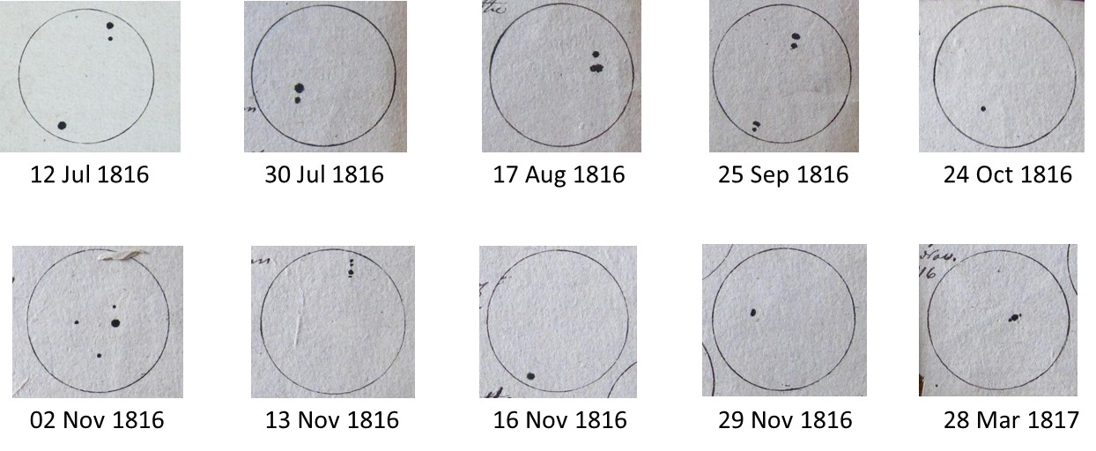
Figure 1. Sunspot Drawings from the Journals of the Reverend Jonathan Fisher.
Submitted to the Space Weather Journal as a News Item or Commentary by W.F. Denig¹ and M.R. McVaugh²
¹NOAA National Centers for Environmental Information, Boulder, CO
²Department of History, University of North Carolina, Chapel Hill, NC

References:
Cathey, B.P. (2015), Reverend Jonathan Fisher: One Thread in the Web of Early American Education, 1780-1830, Thesis, 98 pp., The University of Maine, Orono, ME.
Fagan, B. (2001), The Little Ice Age: How Climate Made History 1300-1850, ISBN: 978-0-465-02272-4, 272 pp., University of Michigan, Ann Arbor, MI.
McCracken, K. G., and J. Beer (2014), Comparison of the extended solar minimum of 2006–2009 with the Spoerer, Maunder, and Dalton Grand Minima in solar activity in the past, J. Geophys. Res. Space Physics, 119, 2379–2387, doi:10.1002/2013JA019504.
Klingaman W.K. and N.P. Klingaman (2013), The Year Without Summer: 1816 and the Volcano That Darkened the World and Changed History, ISBN: 978-0-312-67645-2, 338 pp., St. Martin’s Press, New York, NY.
Murphy, K.D. (2010), Jonathan Fisher of Blue Hill Maine, ISBN: 978-1-55849-743-6, 336 pp., University of Massachusetts Press, Amherst, MA.

Author Biographies
William F. Denig is the Solar-Terrestrial Program Manager within the NOAA National Centers for Environmental Information

Michael R. McVaugh is William Smith Wells Professor of History Emeritus (history of science) at the University of North Carolina, Chapel Hill

Supporting Materials
FIGURES

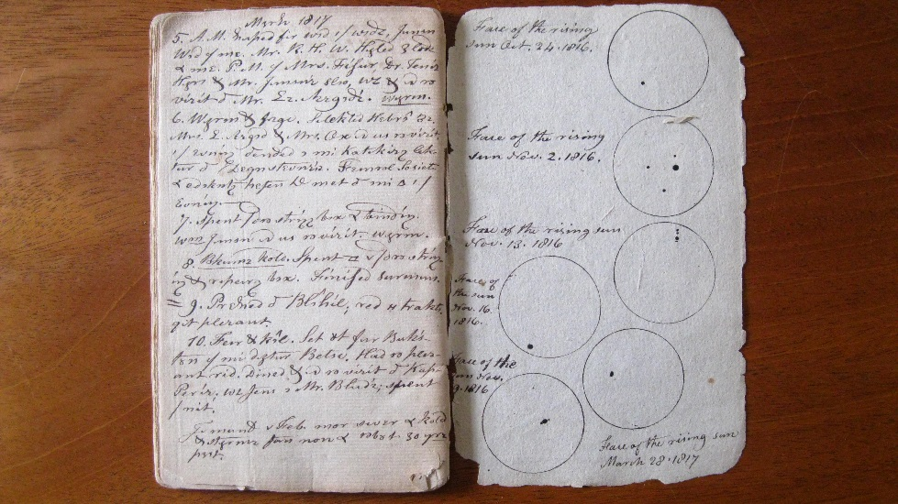
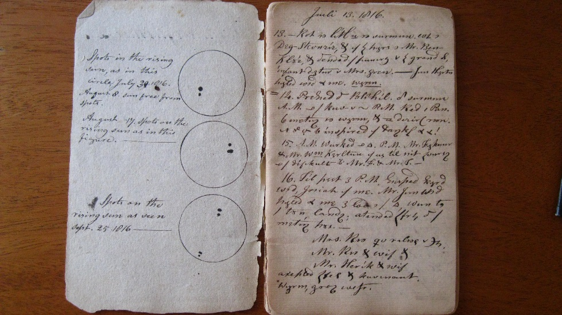
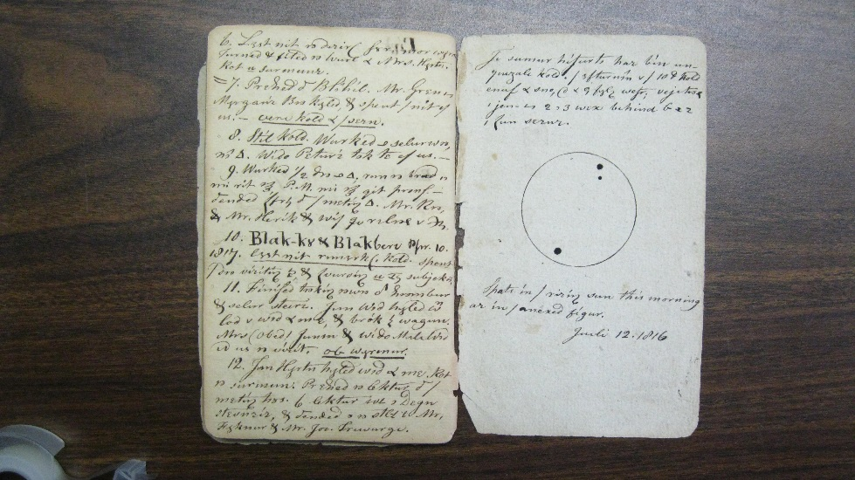
Figure 2

Figure 3

REFERENCES – Jonathan Fisher
Cathey, B.P. (2015), Reverend Jonathan Fisher: One Thread in the Web of Early American Education, 1780-1830, Thesis, The University of Maine, 98 pages.
Jonathan Fisher was a remarkably gifted man with a passionate interest in the education of the future generations of Maine citizens. No historian, however, has yet to examine Jonathan Fisher’s connection to American educational trends. Primary and secondary schools had existed in colonial America since the 1630s. Fisher witnessed and participated in the transformation of American schooling through his involvement in the local schools, libraries and education within his home, his establishment and maintenance of the Blue Hill Academy and the Bangor Theological Seminary and the publication of his juvenile works The Youth’s Primer and Scripture Animals.
The first chapter of the thesis will first begin by examining the works of those who have already studied the life and accomplishments of the Reverend Jonathan Fisher. There will be a particular focus on the works of Mary Ellen Chase and Kevin D. Murphy. The chapter will then study the manuscripts of Bernard Bailyn, Lawrence Cremin, and James Axtell who were concerned with the educational development of colonial and federal America. The chapter will end with an analysis of the works of Donald M. Scott and Stephen A. Marini who investigated the role of the New England minister in the late-eighteenth and early-nineteenth centuries.
The second chapter will analyze Fisher’s primary educational contributions. The chapter begins with an examination of primary education during the period and proceeds with an evaluation of Fisher’s role as a teacher and supporter of education. This chapter relies mostly on Fisher’s journals as a primary source. The third chapter evaluates Fisher’s influence upon secondary education, particularly the Blue Hill Academy and the Bangor Theological Seminary. The prevalent primary sources include Fisher’s journal and student workbooks and the secondary source The Academies of Blue Hill Maine.
The thesis concludes with an examination of Fisher’s educational works The Youth’s Primer and Scripture Animals. The chapter begins with a short history of primers and closes with an analysis of The Youth’s Primer and Scripture Animals. Jonathan Fisher was a Congregational minister on the Maine frontier; however he also desired to incorporate Blue Hill into the greater American intellectual culture. This thesis utilizes Fisher’s journals and other reliable primary and secondary sources in order to secure his place as an essential component to the development of education in the greater Penobscot area.
Murphy, K. D. (2010), Jonathan Fisher of Blue Hill, Maine, 336 pages, ISBN 978-1-55849-743-6, University of Massachusetts Press, Amherst, MA
This book examines the life of Jonathan Fisher (1768–1847), a native of Braintree, Massachusetts, and graduate of Harvard College who moved in his late twenties to Blue Hill, Maine, where he embarked on a multifaceted career as a pioneer minister, farmer, entrepreneur, and artist. Drawing on a vast record of letters, diaries, sermons, drawings, paintings, and buildings, Kevin D. Murphy reconstructs Fisher’s story and uses it to explore larger issues of material culture, visual culture, and social history during the early decades of the American republic.
Murphy shows how Fisher, as pastor of the Congregational church in Blue Hill from 1796 to 1837, helped spearhead the transformation of a frontier settlement on the eastern shores of the Penobscot Bay into a thriving port community; how he used his skills as an architect, decorative painter, surveyor, and furniture maker not only to support himself and his family, but to promote the economic growth of his village; and how the fluid professional identity that enabled Fisher to prosper on the eastern frontier could only have existed in early America where economic relations were far less rigidly defined than in Europe.
Among the most important artifacts of Jonathan Fisher’s life is the house he designed and built in Blue Hill. The Jonathan Fisher Memorial, as it is now known, serves as a point of departure for an examination of social, religious, and cultural life in a newly established village at the turn of the nineteenth century. Fisher’s house provided a variety of spaces for agricultural and domestic work, teaching, socializing, artmaking, and more.
Through the eyes of Jonathan Fisher, we see his family grow and face the challenges of the new century, responding to religious, social, and economic change—sometimes succeeding and sometimes failing. We appreciate how an extraordinarily energetic man was able to capitalize on the wide array of opportunities offered by the frontier to give shape to his personal vision of community.
Wikipedia – Jonathan Fisher (Downloaded 11 April 2017)
Parson Jonathan Fisher (1768–1847) was the first Congregational minister from 1794 to 1837 in the small village of Blue Hill, Maine in the United States. Although his primary duties as a country parson engaged much of his time, Fisher was also a farmer, scientist, mathematician, surveyor, and writer of prose and poetry. He bound his own books, made buttons and hats, designed and built furniture, painted sleighs, was a reporter for the local newspaper, helped found Bangor Theological Seminary, dug wells, built his own home and raised a large family.
Truly a renaissance man in the breadth of his accomplishments Fisher invites comparison with a Franklin or Jefferson. In his manners, morals and writings Fisher represents the best of the vigorous New England churchmen who shaped the standards of their congregations during America's formative years.
Biographical information - Jonathan Fisher was born in [[New Braintree, Massachusetts]] in 1768 and reared in the home of his uncle a minister, because his father, a American Revolutionary War|Revolutionary War soldier had died. As a young man he considered becoming a blacksmith, cabinet maker or clockmaker, but his intellectual gifts were evident and his family was able to send him to Harvard in 1788. He studied liberal arts and divinity, supporting himself by waiting on other students in the dining hall. During this time he developed a curious shorthand or code in which his notes were kept.
He came to Blue Hill Maine in 1796 as the first settled pastor of the Congregational Church. By November 2, 1797, his original house was completed by the work of his own hands, aided by those of his parishioners. The first house, which was in use for 100 years, was unfortunately torn down by a Fisher descendant in 1896. It formed the shell of the present house which was begun in 1814, again largely by the parson himself. His skill and taste as a builder and designer are evident in its rooms.
The Reverend Jonathan Fisher, Master of Arts, a degree and title in which he took much pride, was a most unusual and remarkably gifted man. When at the close of the 18th century he came to Blue Hill, then a frontier village "in a wilderness", he was seemingly leaving behind him all those intellectual and artistic pursuits and resources in which he delighted. Yet, instead of leaving these in the "Seat of the Muses", which was his name for Harvard College and Cambridge, he transported them to his lonely, far-flung parish, and with no little success, grafted many of them upon the people, and upon the pioneer institutions of his new charge.
A student of languages all his life, he did not neglect his Hebrew, his Latin, or his Greek. In his study on the right entrance to his house, he read his Hebrew Bible at five o'clock each morning, in winter by the light of his "blazing logs"; his Latin and Greek he taught to four or five young men, who usually boarded with him and his own large family. Devoted to drawing and painting, he somehow managed to pursue these arts even in Blue Hill.
Industrious almost beyond belief, and possessed of an unflagging physical vitality, he relieved his omnipresent poverty and increased the few hundred dollars of his meager salary by farming his own acres, concocting medical remedies, braiding numberless straw hats, sawing out buttons from the bones of farm animals, and even of dead household pets, painting names on vessels or painting sleighs (at $2.50) each, making pumps, chairs, chests, hair-combs, tables, bureaus, bedsteads, cradles, even drumsticks for the local militia (at 25 cents a pair), and by repairing much of the shaky furniture in Blue Hill. And, with all these labors, he found time to write many poems, and several books.
Nor were his activities confined to his parish. Although he nurtured its library, was the power behind its Academy, founded in 1803 (in which he encouraged "the fine arts" as well as the study of classics and mathematics), and watched over the minds as well as the souls of its people, he went on long missionary journeys, was an active Trustee of the Bangor Theological Seminary (and an untiring beggar for its needs as well!). He was an ardent speaker and writer in the cause of bettering the lot of the Negroes and sponsored from its beginning the American Society for the Colonization of Liberia.
Through these and other labors both and home added immeasurably to the cultural dignity of this village for more than half a century. Blue Hill still respects and honors him
The Blue Hill Congregational Church - No one can hope to understand Jonathan Fisher unless they realize that first and foremost he was a [[Calvinist]] minister. He lived his life in obedience to the precepts of his religion and did his utmost to defend the faith as he understood it. In his writings, his artwork, but perhaps most of all in the example of his life he strove to center his attention on his religious duties.
The Calvinist's believed that the chief end of man was "to know and do the will of God". Fisher constantly chided himself for his pleasure in "temporal" matters such as painting, mathematics, etc. which he believed took away from his primary religious responsibilities both to himself and his congregation.
In Jonathan Fisher's time the Calvinist religion was strong throughout [[New England]]. It was a stern religion, even by the standards of the day. Calvinists believed that God is infinite and transcendent. To know the will of God is man's supreme end. This will is known to man through the scriptures, whose writers were "sure and authentic amanuenses of the Holy Spirit". While God is the source of all good, man is guilty and corrupt from birth. To redeem man, the Son of God became incarnate in the person of Jesus Christ.
When man is united to Christ, the benefits of salvation are achieved. This union is achieved only through the special operation of the Holy Spirit in the faithful. This assurance which the believer has of salvation rests on the divine choice of the man to salvation; and this falls back on God's eternal sovereign purpose, whereby He has predestined some to eternal life and some to eternal death. The former he calls to salvation, and they are kept by him in progressive faith and holiness.
The Calvinist Church is universal, with the multitude gathered from diverse nations agreeing on the tenets of one common faith. This universalism may explain why Fisher campaigned so strongly for better treatment for Native Americans. He was also very active in the attempt to eliminate slavery by proposing that slaves be purchased from their owners and sent back to Africa as free men and women.
The pastor played a central role in the Calvinist Church. He not only administered the sacraments, but also was responsible for maintaining church discipline - admonishing, or even excommunicating those who failed to abide by church doctrine. Over time and as new sects such as the Baptists entered the Blue Hill region, the severity of the Calvinist doctrine became less acceptable to the congregation. Fisher, however, never wavered from his sense of duty. "Father" Fisher, as he liked to be called, spent his years supporting and maintaining the faith that he first embraced as a young man.

References – Year Without a Summer
Narron, J. and D. Morgan (2014), Crisis Chronicles: The Crisis of 1816, the Year without a Summer, and Sunspot Equilibria, Liberty Street Economics, 03-Oct-2014
1816: The Year without a Summer - The financial and economic difficulties associated with the end of the Napoleonic wars were exacerbated by extremely cold, dark weather across northern Europe and the northeastern United States in 1816. The poor weather was caused by the eruption in the Dutch East Indies (Indonesia) of Mount Tambora, which spewed smoke and ash into the atmosphere, obscuring the sun. So severe was the weather that snow was recorded in Albany, New York, and in cities in northern Europe—in July. The cold and dark caused widespread crop failures and severe famine across the Northern Hemisphere, and 1816 became known as the “Year without a Summer” and the “Poverty Year.” People were observed eating “bread” of sawdust and straw. Lord Byron commemorated the calamity with a poem, “Darkness.”
A Sunspot Equilibrium? Not Really - The “Poverty Year” may have been aggravated by historically low sunspot activity around 1816. As explained by Soon and Yaskell, sunspots are manifestations of the amount of solar magnetic activity. Somewhat counterintuitively, the more sunspots there are on the surface of the sun, the brighter the sun is. Sunspot activity was unusually low in the period surrounding and including 1816—thirty-five sunspot groups were observed in 1816, compared with the normal one hundred, with 1816 falling about two-thirds of the way into the “Dalton Minimum,” a period of low solar activity that lasted from 1790 to 1830—and this lack of solar activity may have contributed to the cold and dark. And despite five sunspots appearing on June 10, 1816, six on June 12, and eight on June 16, all abnormally large and visible to the naked eye owing to the filtering effects of the excess particles in the atmosphere, sunspots didn’t reappear in greater numbers until September—too late to affect the 1816 harvest. As early as 1816, Scots Magazine began to draw some conclusions between sunspots and the price of wheat.

Curiously, there is a concept in modern economics known as “sunspot equilibria.” The concept refers to the theoretical possibility that economic outcomes can be altered by a random, extrinsic variable (for example, a sunspot or animal spirits, per Keynes) that has nothing to do with economic fundamentals such as endowments, technology, or preferences. The possibility was first laid out in the context of a particular class of general equilibrium economic models in a classic paper by the economists David Cass and Karl Shell, “Do Sunspots Matter?” Of course, any effect of the low sunspot activity in 1816 wouldn’t qualify as a sunspot equilibrium since the low solar activity may have had real (intrinsic) effects on the climate and hence, crop harvests. In general, there isn’t much evidence for sunspot equilibria, although there is some evidence that sunshine has a small but statistically significant effect on stock returns.

References:
Year Without a Summer, Wikipedia; link: https://en.wikipedia.org/wiki/Year_Without_a_Summer, last accessed 19 Sept 2016.
Matthes, F.E. (1939): Report of the Committee on Glaciers, April 1939. Transactions of the American Geophysical Union, 20: 518–523.
Matthews, J.A. and Briffa, K.R.(2005), The ‘Little Ice Age’: re-evaluation of an evolving concept., Geogr. Ann., 87 A (1): 17–36
Wagner, Sebastian and Eduardo Zorita (2005) "The influence of volcanic, solar and CO2 forcing on the temperatures in the Dalton Minimum (1790–1830): a model study", Climate Dynamics v. 25, pp. 205–218, doi 10.1007/s00382-005-0029-0.

