Data Stewardship for the NOAA DSCOVR Spacecraft
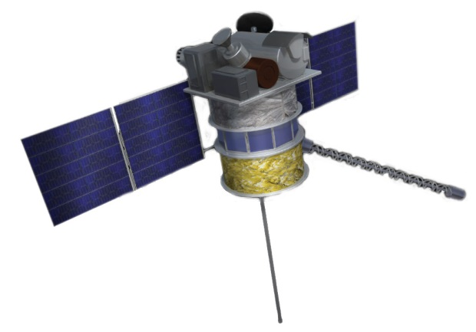
The Deep Space Climate Observatory (DSCOVR) will be NOAA’s space weather sentinel at the Sun-Earth Lagrange (L1) point located some 240 Earth radii in the sunward direction. From this vantage point DSCOVR will provide a 30 to 45 minute advanced warning of deleterious solar storm conditions by continuously monitoring the density and speed of the solar wind and of the interplanetary magnetic field (IMF). Solar storms can adversely affect modern technology systems such as satellites, communications networks and terrestrial power grids that are vulnerable to space weather. NOAA is the Nation’s civil provider of operational space weather alerts and warnings whereas the U.S. Air Force (USAF) provides space weather services for Department of Defense users. Since 1997 NOAA has depended on NASA’s research satellite, the Advance Composition Explorer (ACE), to provide nearly continuous measurements of the solar wind and IMF. Planned as a nominal 2-year mission, the ACE satellite has long outlived its design lifetime and is at imminent risk of failure. Through the teaming efforts of NOAA, NASA and the USAF the DSCOVR spacecraft will assume the responsibility for space weather monitoring in mid-2015 following the launch in January 2015.
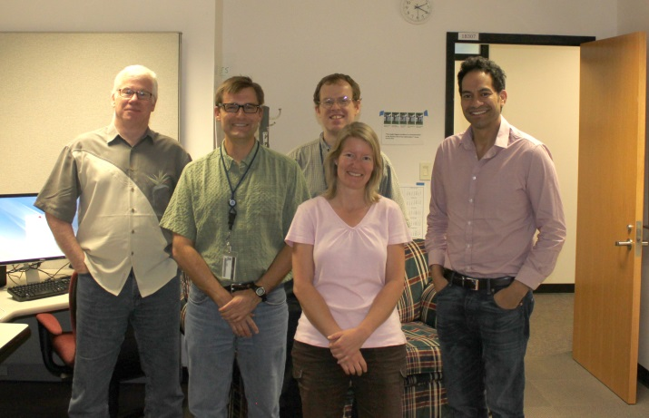
The NOAA National Geophysical Data Center (NGDC) is responsible for stewarding the DSCOVR data including managing the long-term archive and providing user access to data and higher-level products. Whereas real-time access to DSCOVR data is provided by the NOAA Space Weather Prediction Center (SWPC) for space weather operations, the focus of NGDC is providing retrospective access to these data for scientific research. Within the DSCOVR program, NGDC is also responsible for ensuring that instrument scientists have access to these data for instrument calibration and sensor health and status. The DSCOVR team within NGDC has completed the development of the data ingest-to-archive-to-delivery system which ensures that DSCOVR data will be preserved, discoverable, and readily accessible to NOAA constituents. Taking advantage of infrastructure components within NGDC the team has utilized Common Ingest (CI) for acquiring DSCOVR data from SWPC and the NGDC Extract (NEXT) for serving these data to users using modern RESTful services as well as providing a Graphical User Interface (GUI) to the data.

