Training Handout – Quick Start Guide – SDO/AIA
1 – Open link to Helioviewer: “https://www.helioviewer.org/”
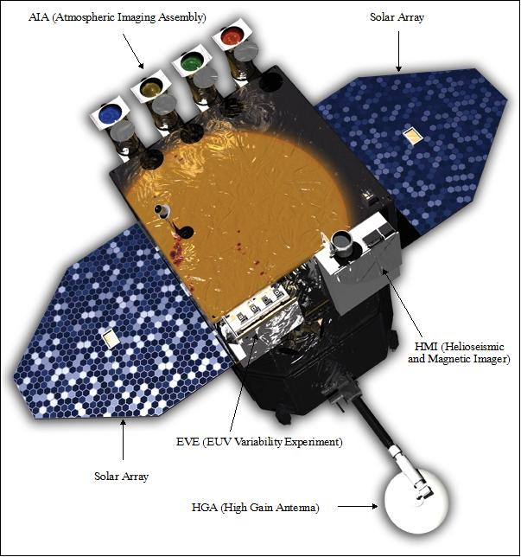
- Expand/Set “Images”
2 – Select Observatory: SDO
3 – Select Instrument: AIA
4 – Select Measurements: 304
- Expand/Set “Observation Time”
5 – Select Date: 2015/04/20
6 – Select UTC: 15:00:00
7 – Select Jump: 1 day
8 – Step forward/backwards to observe daily progression of active regions across the solar disk
- Expand/Set “Features and Events”
9 – Click “Active Regions” to take advantage of “Heliophysics Events Knowlebase”
- Table of Events (for the student):
Date | UTC | Jump | Obs | Inst | Meas | Feature
2012/10/23 | 03:17:03 | 1 min | SDO | AIA | 94 | Solar Flare {X1.8: 0313 0321 0317}
2012/07/12 | 17:00:00 | 15 min | SDO | AIA | 131 | Solar Flare {X1.4: 1537 1730 1649}
2015/04/20 | 15:00:00 | 1 day | SDO | AIA | 171 | Active Regions
2015/10/10 | 04:00:00 | 1 day | SDO | AIA | 193 | Coronal Hole
2015/09/10 | 15:00:00 | 1 day | SDO | AIA | 211 | Coronal Hole(s)
2013/05/01 | 02:30:00 | 5 min | SDO | AIA | 304 | Coronal Mass Ejection
