IHB File No. S3/2636
CIRCULAR LETTER 11/2016

01 March 2016

REQUEST FOR SHALLOW WATER BATHYMETRIC DATA

References:
A. IHO Circular Letter 36/2006 dated 28 March 2006 – Request for Shallow Water Bathymetric Data.
B. IHO Circular Letter 14/2007 dated 02 February 2007 - Request for Shallow Water Bathymetric Data.

Dear Hydrographer,

- References A and B invited IHO Member States to provide sounding data extracted from Electronic Navigational Charts (ENC), in order to improve the ocean grid compiled and published as part of the Joint IHO-IOC General Bathymetric Chart of the Oceans (GEBCO) Project. Through this initiative, twenty one Member States and one Regional Hydrographic Commission have generously provided depth data that has resulted in significant improvements to the GEBCO Grid. Figure 1 (Annex A) shows the areas where ENC sounding data have been contributed so far and Figure 2 (Annex B) is an example illustrating how these data have helped improve the GEBCO grid.

2. In addition to bathymetry data extracted from ENCs, GEBCO’s global grid has benefited from consolidated shallow water bathymetry data sets, provided by hydrographic organizations through regional mapping projects such as the European Marine Observation and Data Network (EMODnet) for European waters and the Baltic Sea Bathymetry Database.

3. In its review of progress of the GEBCO Grid, the GEBCO Guiding Committee (GGC), at its 32nd meeting held in Kuala Lumpur, Malaysia, in October 2015 recognized the substantial increase in ENC coverage over the past 10 years. As a result, the GGC asked the IHB to invite once again, those Member States that have not already provided sounding data from their ENCs to do so.

4. The East Asia Hydrographic Commission and the following Member States who have already provided shallow water bathymetry data from their ENCs or through regional mapping programs to GEBCO need not do so again unless they consider that the bathymetry included in their ENCs has improved significantly since their previous submissions: Australia, Bahrain, Belgium, Chile, Ecuador, Finland, Germany, Greece, India, Italy, Republic of Korea, Latvia, Malaysia, Netherlands, Norway, Peru, Poland, Portugal, South Africa, Sweden and USA.

5. As reported in References A and B, soundings extracted from ENC usage bands 2 (General) and 3 (Coastal) are the most suitable. Only the depth contour (DEPCNT) and sounding (SOUNDG) geo objects are required for improving the GEBCO grid bathymetry. It should also be noted that these objects will not be included directly in any of the GEBCO products. They will only be used as source data to improve the accuracy and quality of the derived GEBCO Grid.

6. All submissions of data should be forwarded to IHB Assistant Director Anthony Pharaoh (addt@iho.int) using the S-57 (xxx.000) format or any other common GIS format. Contributors are requested to indicate whether their data is being provided solely for GEBCO purposes, or whether it can also be included in the IHO Data Centre for Digital Bathymetry (DCDB).

7. The latest GEBCO Grid can be downloaded from the GEBCO website (www.gebco.net > Home > Data and products > Gridded bathymetry data) together with a free viewing software application. The grid can also be freely accessed as a Web Map Service from the GEBCO web site.

On behalf of the Directing Committee
Yours sincerely,

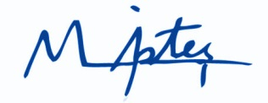

Mustafa IPTES
Director

Copy to: The Chairs of the Regional Hydrographic Commissions

Annexes:
Annex A: Figure 1 – Areas where ENC sounding data have been provided.
Annex B: Figure 2 – Example showing improvements in the GEBCO Grid resulting from data extracted from ENCs.

Annex A to IHO CL 11/2016

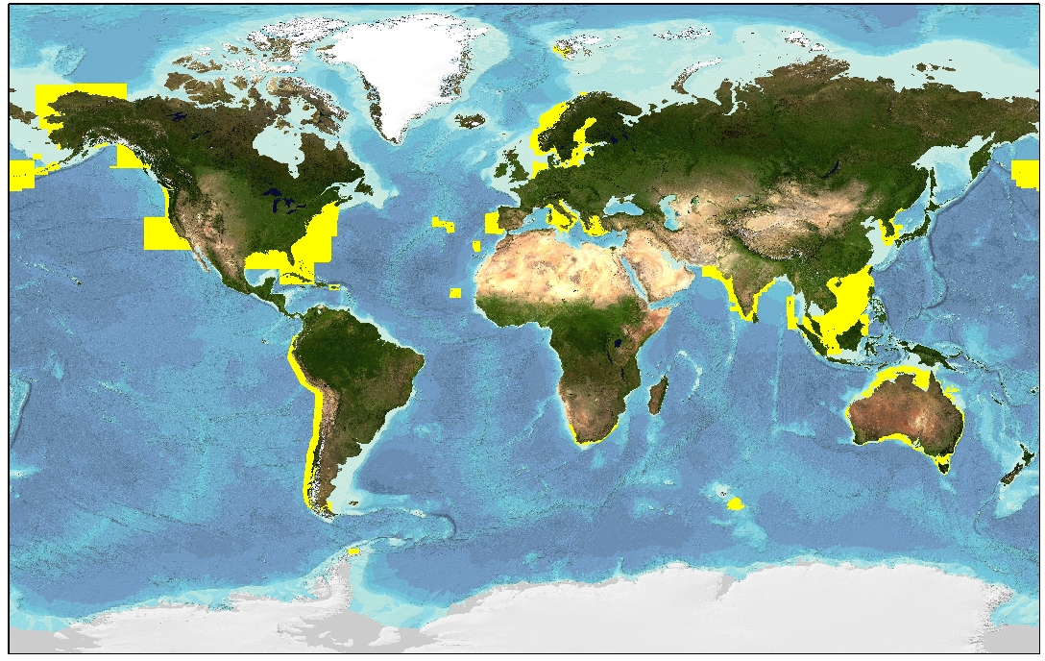

Figure 1 – Areas where ENC sounding data have been provided.

Annex B to IHO CL 11/2016

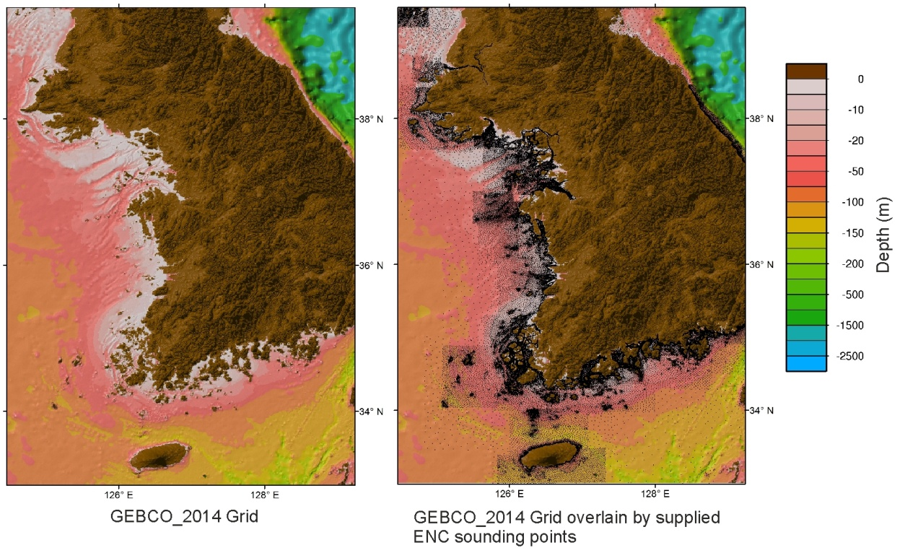

Figure 2 – Example showing improvements in the GEBCO Grid resulting from data extracted from ENCs (in this case, provided by the Republic of Korea).

